EARTHBOUND ON
WII VIRTUAL CONSOLE!


You’ve played as Ness in Super Smash Bros., now you can play the game that first made him famous!

Join Ness and his three friends to defend the world from the universal cosmic destroyer in EarthBound, now available on the Wii Virtual Console for only $8! That’s $242 cheaper than buying it new on eBay!

IN EARTHBOUND YOU’LL FIGHT:

- Hippies with toothbrush obsessions
- Talking piles of vomit
- Boozed-up businessmen
- Zombie dogs
- Living, maniacal taxicabs
- Melting clocks
- Floating electric eyeballs
- Cult leaders
- Haunted guitars and coffee cups

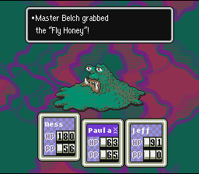
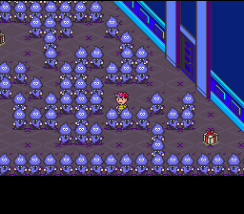
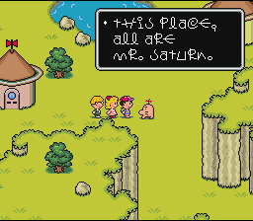
See all this and MUCH more in the modern-day RPG that spawned a massive cult following and has gaming magazines talking about it even 12 years after its release! Download it today on your Nintendo Wii Virtual Console!

