EARTHBOUND ON
WII VIRTUAL CONSOLE!


You’ve played as Ness in Super Smash Bros., now you can play the game that first made him famous!

Join Ness and his three friends to defend the world from the universal cosmic destroyer in EarthBound, now available on the Wii Virtual Console for only $8! That’s like $40 cheaper than buying the cheapest used copy on eBay!

IN EARTHBOUND YOU’LL FIGHT:

- Exploding trees
- Putrid moldy men
- Walking hieroglyphs
- Insane bag ladies
- Cavemen who eat picnic lunches
- Mutant fish-tribesmen things
- Gigantic plague rats of doom
- Zombies from bad B-movies
- Martial artist policemen

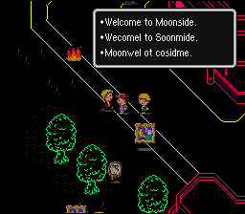
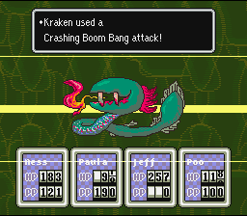
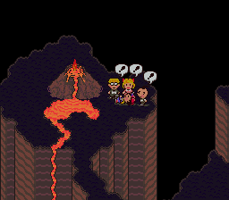
See all this and MUCH more in the modern-day RPG that spawned a massive cult following and has gaming magazines talking about it even 12 years after its release! Download it today on your Nintendo Wii Virtual Console!

